Breadth-First Search (BFS)

Aim
To write and execute a Python program to implement Breadth-First Search (BFS) traversal of a graph.

Algorithm
- Start from the source node.
- Mark the node as visited.
- Insert it into a queue.
- Remove the front node from the queue.
- Visit all unvisited adjacent nodes and add them to the queue.
- Repeat until the queue becomes empty.

Procedure
- Open a Python IDE.
- Enter the BFS program.
- Save it with a .py extension.
- Run the program.
- Observe the BFS traversal order.
Code
from collections import deque
graph = {
'A': ['B', 'C'],
'B': ['D', 'E'],
'C': ['F'],
'D': [],
'E': ['F'],
'F': []
}
visited = set()
queue = deque(['A'])
print("BFS Traversal:")

while queue:
node = queue.popleft()
if node not in visited:
print(node, end=" ")
visited.add(node)
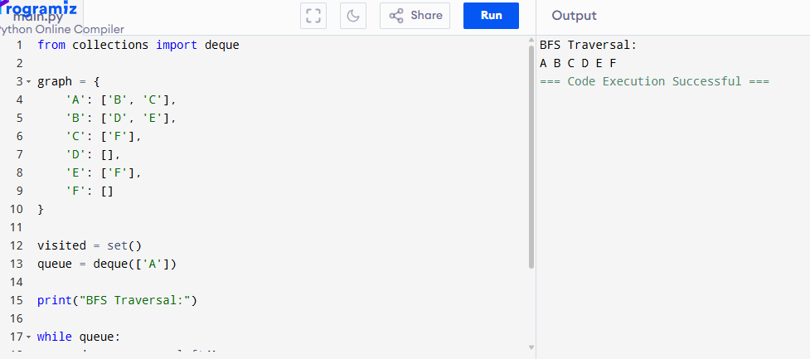
queue.extend(graph[node])

Result
The BFS traversal was executed successfully, and all graph nodes were visited level by level.

Depth-First Search (DFS)

Python Program
graph = {
'A': ['B', 'C'],
'B': ['D', 'E'],
'C': ['F'],
'D': [],
'E': ['F'],
'F': []
}
visited = set()
def dfs(node):
if node not in visited:
print(node, end=" ")
visited.add(node)

for neighbour in graph[node]:
dfs(neighbour)
print("DFS Traversal:")dfs('A')

Aim
To write and execute a Python program to implement Depth-First Search (DFS) traversal of a graph.

Algorithm
- Start from the source node.
- Mark the node as visited.
- Visit the first unvisited adjacent node recursively.
- Continue until all reachable nodes are visited.
- Backtrack whenever no unvisited neighbor exists.

Procedure
- Open a Python IDE.
- Type the DFS program.
- Save the file.
- Run the program.
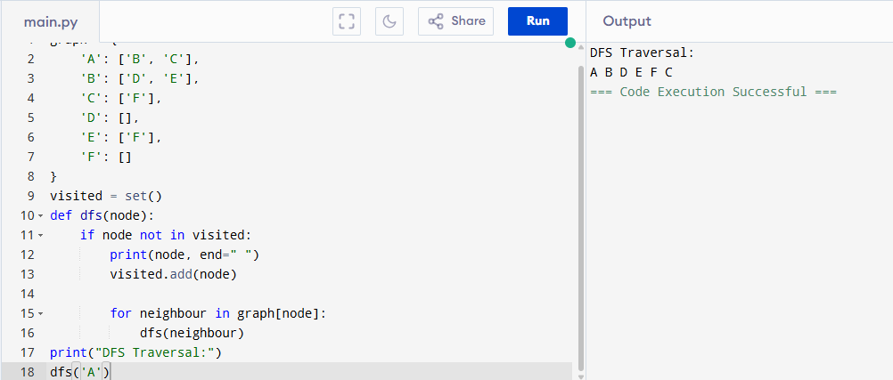
- Observe the DFS traversal order.

Result
The DFS traversal was executed successfully, and all graph nodes were visited using recursion.

Travelling Salesman Problem (TSP)

Python Program
from itertools import permutations
graph = [
[0, 10, 15, 20],
[10, 0, 35, 25],
[15, 35, 0, 30],
[20, 25, 30, 0]
]
cities = [1, 2, 3]min_cost = float('inf')
for path in permutations(cities):
cost = 0
k = 0

for city in path:
cost += graph[k][city]
k = city

cost += graph[k][0]

min_cost = min(min_cost, cost)
print("Minimum Cost:", min_cost)

Aim
To write and execute a Python program to solve the Travelling Salesman Problem (TSP).

Algorithm
- Represent the cities using a cost matrix.
- Generate all possible routes using permutations.
- Calculate the total travel cost for each route.
- Compare the costs.
- Display the route with the minimum cost.

Procedure
- Open a Python IDE.
- Enter the TSP program.
- Save it with a .py extension.
- Execute the program.
- Observe the minimum travel cost.
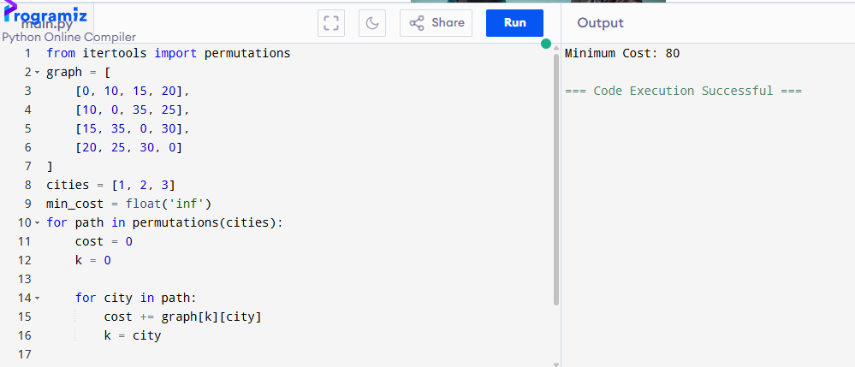

Result
The program was executed successfully, and the minimum travel cost for the Travelling Salesman Problem was obtained.

A* Search Algorithm

Python Program
from queue import PriorityQueue
graph = {
'A': [('B', 1), ('C', 3)],
'B': [('D', 3), ('E', 6)],
'C': [('F', 5)],
'D': [],
'E': [('G', 2)],
'F': [('G', 2)],
'G': []
}
heuristic = {
'A': 7,
'B': 6,
'C': 4,
'D': 3,
'E': 2,
'F': 1,
'G': 0
}
def astar(start, goal):
pq = PriorityQueue()
pq.put((0, start))
cost = {start: 0}

while not pq.empty():
_, node = pq.get()

if node == goal:
print("Goal Reached:", goal)
return

for neighbour, weight in graph[node]:
new_cost = cost[node] + weight

if neighbour not in cost or new_cost < cost[neighbour]:
cost[neighbour] = new_cost
priority = new_cost + heuristic[neighbour]
pq.put((priority, neighbour))
astar('A', 'G')

Aim
To write and execute a Python program to implement the A* Search Algorithm.

Algorithm
- Initialize the open list with the start node.
- Calculate the evaluation function f(n) = g(n) + h(n).
- Select the node with the lowest f(n).
- Expand its neighboring nodes.
- Update the path cost and priority.
- Repeat until the goal node is reached.
- Display the goal or optimal path.

Procedure
- Open a Python IDE.
- Enter the A* algorithm program.
- Save the file with a .py extension.
- Run the program.
- Observe the search process and the goal node.

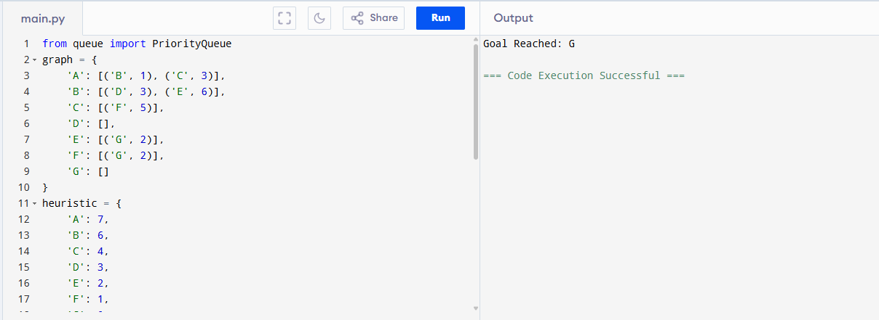

Result
The Python program was executed successfully, and the A* algorithm found the optimal path to the goal node using heuristic information.

